# Future Gold Medalists (Updated)

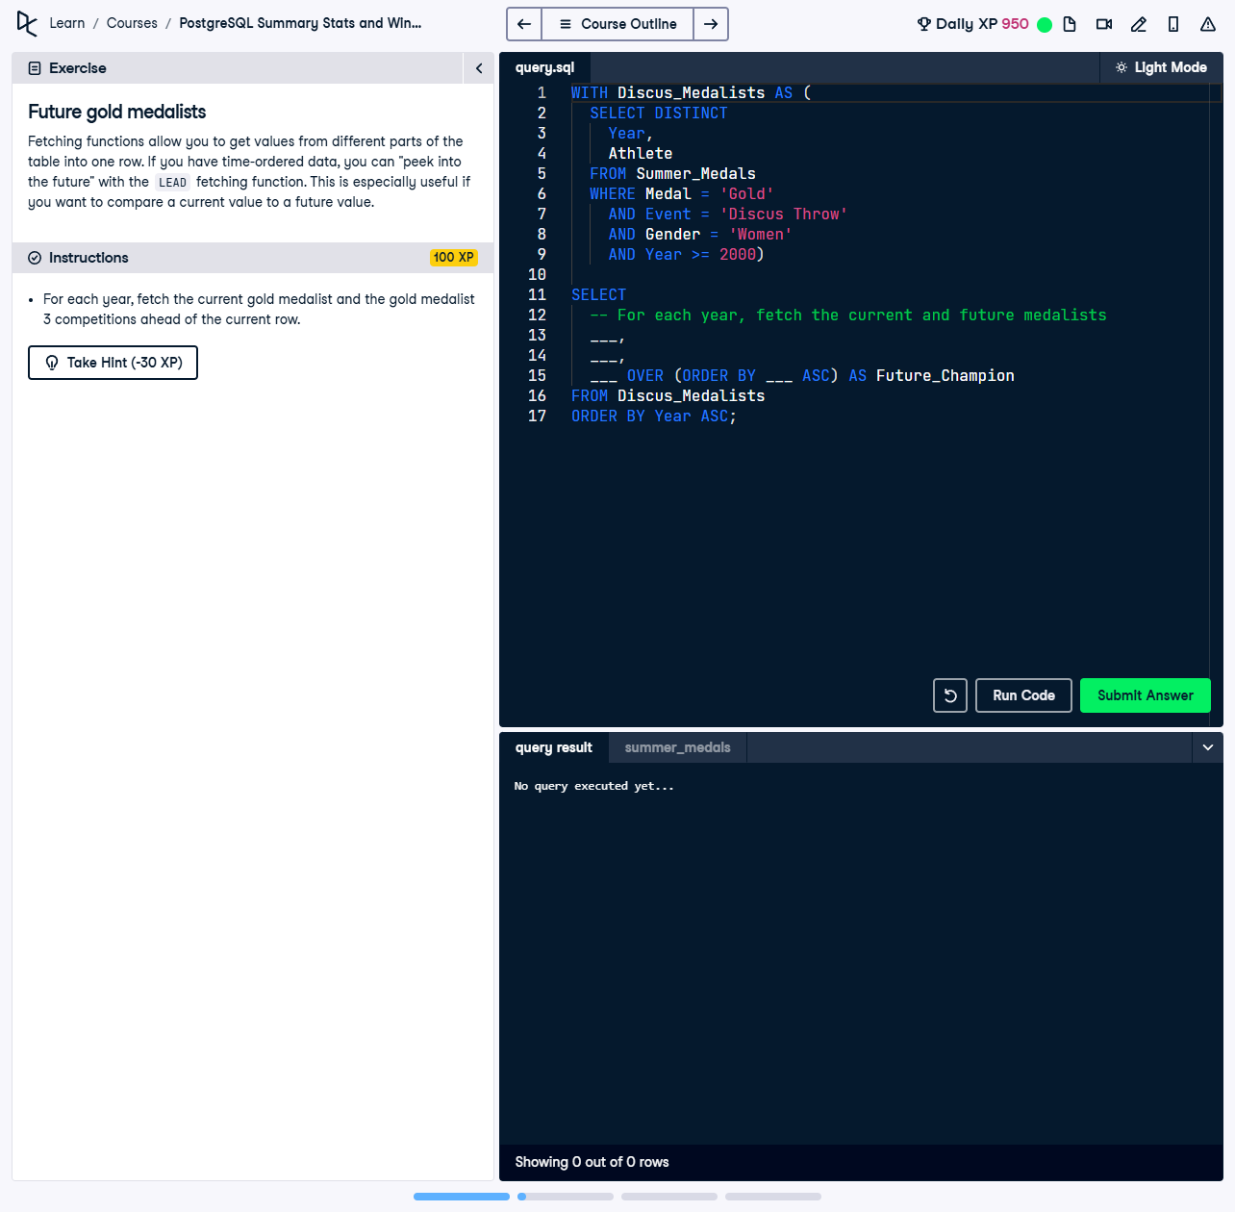

Fetching functions allow you to get values from different parts of the table into one row. If you have time-ordered data, you can "peek into the future" with the `LEAD` fetching function. This is especially useful if you want to compare a current value to a future value.

This exercise involves using a Common Table Expression (CTE) and the `LEAD` function to fetch the current gold medalist and the gold medalist three competitions ahead for women’s Discus Throw events starting from the year 2000.

## Correct Answer

WITH Discus_Medalists AS (  
 SELECT DISTINCT  
 Year,  
 Athlete  
 FROM Summer_Medals  
 WHERE   
 Medal = 'Gold' AND  
 Event = 'Discus Throw' AND  
 Gender = 'Women' AND  
 Year >= 2000  
)  
SELECT  
 Year,  
 Athlete,  
 LEAD(Athlete, 3) OVER (ORDER BY Year ASC) AS Future_Champion  
FROM Discus_Medalists  
ORDER BY Year ASC;

Explanation of the query:

1. `WITH Discus_Medalists AS (...)`: This CTE selects unique combinations of year and athlete for women’s Discus Throw gold medalists from 2000 onward, ensuring only relevant results are included.

2. `LEAD(Athlete, 3) OVER (ORDER BY Year ASC) AS Future_Champion`: The `LEAD` function fetches the athlete's name three rows ahead, within the same ordered partition by year.

3. `ORDER BY Year ASC`: Ensures the results are sorted chronologically, aligning current and future champions in the correct sequence.

4. AI Hint: Avoiding unnecessary column renaming in the `SELECT` clause prevents potential mismatches in the output, ensuring consistency.